SCIENCETECH PRODUCTS

- AX-Lightline

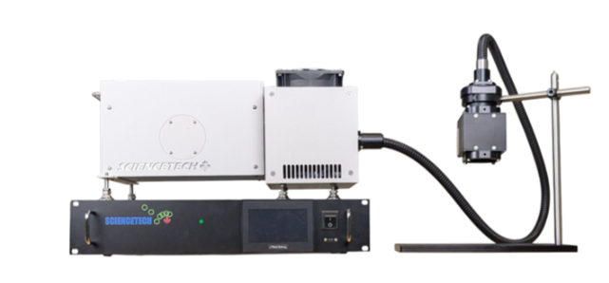
Test Standard: CE Compliant, LighLine Solar Simulators are designed to meet the following standards: ASTM E927-19, IEC-60904-9-Ed.3.

Test Purpose:

The Sciencetech LightLine series of fiberized solar simulators are a revolution in the solar simulator industry. With the Lightline, you can direct the Class AAA solar light anywhere you wish with the standard 4 foot fiber. Classic designs for solar simulators require you to bring your sample to the solar simulator. Now you can bring the solar simulator to your sample. The LightLine solar simulators come standard with a touchscreen power supply, integrated shutter, and exposure controller.

The LightLine has one base model and three output optics configurations (custom output optic configurations are available). Configuration options exist for Class AAA illumination up to 50 mm square and intensity up to 18 Suns.

Applications: Testing photovoltaic cell performance, Photochemistry, Photobiology, Photocatalytic research, Photosynthesis, Environmental durability testing.

Features:
- Class AAA ASTM standard
- Fiberized output for flexible illumination
- Easy-to-use touchscreen controls
- Light intensity control available
- Up to 18 Suns intensity
- Remote control by PC
- Cost-effective for researchers
- Spectral range 350-1800 nm
- Easy glovebox integration

Technical Specifications:

MODEL | AX-100 | AX-200 | AX-400
Target Area | 10 × 10 mm | 25 × 25 mm | 50 × 50 mm
Sun Level | 18 Suns | 4 Suns | 1 Sun
Spectral March | A
Spatial Non-Uniformity | A
Temporal Instability | A
Wavelength Range | 350 - 1800 nm
Working Distance | 90 - 110 mm | 190—210 mm | 390 - 410 mm
Air Mass Filters | AM1.5G, AM1.5D
Lamp | 300 W Xenon, 900 h (average) Lifetime, Forced Air Cooling
Shutter | Integrated Touchscreen Control, 0 - 10000s, Adjustable Duty Cycle
Fiber Bundle Length | 1.22m (4’) Standard
Power Supply Model | 601-300
Input Voltage/Current | 100-240 VAC, 6 A - 3 A
Environment | Temperature 10-35°C , Humidity 20-80% , Non-condensing
Dimension (L × W× H) | See Dimensions Page
Weight | 15 kg

- Fully Reflective Solar Simulator

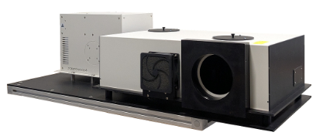

Test Standard: CE Compliant.

Test Purpose:

Sciencetech manufactures three high powered version of Class BBA fully reflective solar simulators.
Sciencetech’s proprietary fully reflective design uses metal coated mirrors and passes the whole spectrum, no compromise. This is a distinct advantage over refractive based systems that are limited by the properties of the transparent material used.

Applications: Photovoltaic testing, Exposure testing, Light bleaching, High UV tests.

Features:

- Class BBA solar simulators
- Xenon short arc lamp
- Fully reflective optical system
- No chromatic aberration
- A variety of available filters
- Modular design
- Many optional components

Technical Specifications

Models | SS0.5kW | SS1.0kW | SS1.6kW
Specification | 165-9002 | 165-9001 | 165-9007
Solar Simulator Type | Steady-State
Target diameter (mm)¹ | 76.2 | 127 | 152.4
Target Diameter (mm)¹ | 70 | 115 | 140
(with CTBT-SS or DFS-SS ) | 70 | 115 | 140
Beam Orientation² | Horizontal | Horizontal | Horizontal
Working Distance (mm)⁴ | 450 | 750 | 900
Working Distance (mm)⁴ | 310 | 610 | 760
(with CTBT-SS or DFS-SS option) | 310 | 610 | 760
Solar Simulator Classification | BBA
Unfiltered Spectral Range (nm) | 250-2500
Spectral Match Classification³ | B
Spatial Non-uniformity⁴ (%)³ | <5%
Spatial Non-uniformity Class³ | B
Temporal Instability Class³ | A
Temporal Instability (%)³ | <2%
Collimation half angle (deg) | <3°
Lamp Type | Xenon Short Arc
Lamp Power (W) | 500 | 1000 | 1600
Maximum Illumination Intensity⁵ | 1 Sun
Simulator Dimensions (mm) | 1219 x 496 x 356
Simulator Weight (kg) | 60
Control Unit Description | Integrated Touchscreen
Control Unit Model | 611-0.5k | 611-1k | 611-1.6k
Lamp life (hours) | 1500 | 1500 | 2500

- Ultra Power Xenon Arc Lamp Light Sources 6.5kW

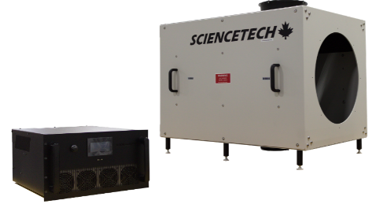

Test Standard: CE Compliant.

Test Purpose:

The UPLH series lamp housing is a modular lamp house design which allows you to customize depending on the required application. Standard offerings include elliptical reflectors, but the lamp house can be easily customized to meet other needs. The Sciencetech UPLH series lamp housing is designed for 6500W Xenon short arc lamps.

The UPLH series lamp housing includes a forced air-cooled fan mounted on the top and bottom panel of the lamp house (when in horizontal operation). The system comes with a glass output window.

Applications: High Temperature Solar Thermal Research (e.g. Heat transfer and energy storage in molten salts research, etc.), Concentrated solar power and liquid-based, solar receivers research, Solar fuel research (e.g. solar hydrogen), Solar syngas, high power solar pyrolysis, high temperature gasification, Photosynthetic Irradiance, Photo biological research, Material testing, Space application, Semiconductor industry, Defense application.

Features:
• Turn-key operation
• Customization available
• Touchscreen and software control
• Safety interlocks

Technical Specifications

Model | UPLH
Lamp Type | Xenon Short Arc (6.5kW)
Optics | Elliptical Reflector,  Protected Aluminum, AL + SiO₂³
F/# | By reflector selection
F/# | F/2.4 (EF) | F/2.7 (E)
Dimensions (L×W×H) | 983 x 713 x 740 mm ⁴
Weight | Lamp House  65 kg | Power Supply  27 Kg
Compatible Power Supply Model | 631-6.5k-220-B (150-9320) | 631-6.5k-480-B (150-9310)
Power Supply Electrical Requirements | 200-240 VAC 3 Phase, 31.3-26.1 A | 380-480 VAC 3 Phase, 16.8-13.3A

- High Collimated Solar Simulator

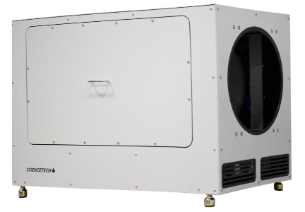

Test Standard: CE Compliant.

Test Purpose:

Sciencetech’s highly collimated solar simulators are designed for photovoltaic cell testing applications where a very high degree of collimation of incident radiation is required. Space environmental simulation (AM0 spectrum), CPV and solar thermal applications generally require light sources with collimation angles approaching that of the sun (0.5 degree). Sciencetech’s highly collimated solar simulators can provide continuous illumination (8” and 11” respectively) and high collimation (0.7 degrees half angle). The system uses Fresnel lens technology to achieve very high collimation. These solar simulators include integrated power supplies and an advanced lamp alignment tool which makes them easy to use.

Applications: Photovoltaic Testing, Solar Thermal System Testing, CPV Systems testing, Space and extraterrestrial solar spectrum simulation, Exposure Related Testing.

Features:

- Xenon short arc lamp.
- High collimation : ± 0.7° (half angle).
- Proprietary Fresnel lens optical system.
- Illumination areas up to 28cm Ø
- Class ABA and AUA models available.
- Optional vertical operation.
- AM1.5G filters included and other AM filters are available.
- Advanced lamp alignment.
- Adaptable framework.
- Simple operation.
- Electronic Shutter.

Technical Specifications

Specification | SHC-1.6K-B | SHC-1.6K | SHC-3.0K-B | SHC-3.0K
Specification | 164-9001 | 164-9005 | 164-9002 | 164-9004
Illumination Area¹  Diameter Ø(AM1.5D) | 20cm Ø |  | 28cm Ø
Illumination Area¹  Diameter Ø(AM1.5G) | 20cm Ø |  | 28cm Ø
Illumination Area¹  Diameter Ø (AM0) | 15cm Ø |  | 21cm Ø
Collimation ² (º) | ± 0.7
Spectral Match Class | A
Filters | AM1.5G is included and other AM filters are available³
Spatial Non-uniformity Class | B | U | B | U
Spatial Non-uniformity⁴ (%) | ±5º | ±25º | ±5º | ±25º
Temporal Instability Class | A
Temporal Instability (%) | <+2
Working Distance (cm) | 20 to 30 |  | 30 to 40
Illumination  Intensity⁵ mW/cm² | With AM0 filter: 137  With AM1.5G filter: 100  Without filters: Up to 200
Beam Orientation | Horizontal
Lamp | 1.6kW Xe Short Arc Lamp |  | 3.0kW Xe Short Arc Lamp
Unfiltered Spectral range | 250-2500nm
Lamp life (hours) | 1500
Power supply | Adjustable constant current supply
Input Voltage (VAC) | 220 - 240
Input Current (A) | 12.1 - 9.0 |  | 19.8 - 16.5
Input Frequency (Hz) | 50/60 Hz
Ripple (%) | < 0.5
Lamp Cooling | Forced air, interlocked to power supply
Dimensions (mm) | 578 x 576 x 522 |  | 819 x 533 x 574
Weight (kg) | 44 |  | 64

- Quantum Efficiency (Personalized PTS Model)

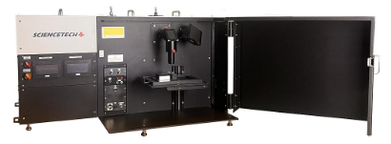

Test Standard: CE Compliant. Compliance: Intended for use in measurements according to ASTM E 1021-15, ASTM E948, IEC 60904-8, IEC 60904-1

Test Purpose:

Sciencetech PTS system conducts SR, EQE, IQE and IV measurements with user friendly software. The system includes a main xenon arc lamp, a monochromator with automated order sorting filters, along with a option for a steady-state solar simulator Class AAA bias light source, measurement electronics, computer, and software required to measure solar cell characteristics. The system provides users with a light tight sample chamber for all measurements. Shielded and light tight test area enclosure has convenient removable cover allowing access from top, front and sides.

Applications: Photovoltaic Solar Cell Testing, IV Characterization, Spectral Response, External Quantum Efficiency-IPCE, Internal Quantum Efficiency (IQE add-on), Photoconductivity Measurement, Reflectance and Transition measurements capability

Features: Spectral Range, 250-2500 nm or 300-5000 nm, Multiple Source Measure Unit options, Lock-in amplifier, Light tight sample chamber, Standard or Extended, User selectable bias voltage, AC and DC measurement mode, SciPV software for full control of the system & manually controlled shutter, Motorized XY stage, optional.

Measurement Capabilities |  | PTS –S (175-9201) | PTS –X (175-9202)
Current-Voltage (IV) Testing | Measures V_{OC} , I_{SC}, R_{shunt}, P_{max}, efficiency %, and fill factor | Included | Included
Spectral Response (SR)* | Scanning range | 250 - 2500 nm | 300-5000 nm
External Quantum Efficiency (EQE) | Incident photon to converted electron ratio (IPCE) | Included | Included
AC and DC measurement mode | Modulated / Continuous measurement capability | Included | Included
Internal Quantum Efficiency (IQE) | The ratio of charge carriers collected by the cell to the number of photons absorbed by the cell | Available as an add-on | Available as an add-on

Technical Specifications

Configuration Description |  | PTS-S (175-9201) | PTS-X (175-9202)
Tunable  Light Source | 150 W Xenon short arc lamp  (1200 hour lifetime) and /or 250W QTH lamp | Xe short arc lamp | Xe +QTH lamp
Tunable  Light Source | · Tuning/scanning range | 250 - 2500 nm | 300 - 5000 nm
Tunable  Light Source | · 1/4 m Czerny-Turner monochromator  with  an adjustable bandpass and motorized  triple grating turret system (3 gratings): | 0.2-24 nm with 1200 l/mm grating @250 nm  0.2-24 nm with 1200 l/mm blaze @500 nm  0.4 - 48 nm with 600 l/mm @1000 nm | 0.4 to 48 nm with 600 l/mm blaze @ 500 nm  0.8 - 96 nm with 300l/mm blaze @ 2000 nm  1.6 - 192 nm with 150l/mm blazed @ 5400 nm
Tunable  Light Source | · Adjustable beam size | 0.5mm - 2.4 mm diameter minimum with standard optics
Tunable  Light Source | · Hard coated order sorting filters | Included | Included
Bias  Light Source | · 150 W or 300W Xenon short arc lamp  average lifetime 1200 hours | Optional, 150W with Standard Sample Chamber, 300W with Extended Sample Chamber
Bias  Light Source | · 25x25 or 50x50 mm AAA, (ASTM E927-19) Solar Simulator
Bias  Light Source | · Includes mounted AM1.5G  filter + additional filter slot
Reference Detector | · Broadband pyroelectric detector,  Element diameter: 5 mm | Included | Included
Reference Detector | · Calibrated range | 250 - 2500 nm | 300-5000 nm
IQE Measurement System | · 50 mm integrating sphere | Optional, available as an add-on
IQE Measurement System | · Internal quantum efficiency  measurement determined from  material reflectance measurement  (hardware included) 250 - 2500nm range.
Measurement System | · Source meter | Optional | Optional
Measurement System | · Measurement time period for 100 IV  points is 17s | Included
Measurement System | · Voltage bias user settable  ±10 V capability | Included
Measurement System | · Lock-in Amplifier | Included
Measurement System | · Chopper 4 - 200 Hz | Included
Measurement System | · Standard auto time constant feature | Included
Measurement System | · Temperature control (10-60 °C) * | Accessory Available
Measurement System | · AC and DC measurement mode | Included
Sample Placement | · 50 × 50 mm simple sample spacer  .for proper placement of the sample  under the monochromatic and bias  light beam. Includes simple  electrical connections. | A simple sample spacer is included, and various cell chucks are available as add-ons
Software  and Interface | · Modern software written in .NET  (Windows 11 Operating System) | Included | Included
Software  and Interface | · Compatible with Windows  10/11, 32/64bit | Included | Included
Software  and Interface | · Data files and automation  log exportable as ASCII | Included | Included
Software  and Interface | · Pre-configured and tested control  computer included | Included | Included
Software  and Interface | · Built in microcontroller switches  and monitors signals automatically | Included | Included
Software  and Interface | · 1 USB port | Included | Included
Software  and Interface | · 1 IEC 60320 C14 power entry inlet | Included | Included
Compliance | Intended for use in measurements  according to ASTM E 1021-15,  ASTM E948, IEC 60904-8, IEC 60904-1 | Included | Included
Power system | · Single phase, configurable for 230 VAC,  50 Hz or 110 VAC, 60 Hz | Included | Included

