SCIENCETECH PRODUCTS

- SciSun Solar Simulator
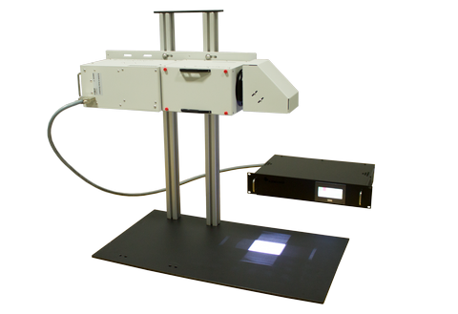
Test Standard: ASTM E927-19, IEC 60904-9, CE Compliant.¹

Test Purpose:

The SciSun line is designed to affordably provide a solution for researchers who require a relatively small field of illumination. They can produce an irradiance of up to 2 Suns and feature Class AAA specifications.

The SciSun series provides a flexible output orientation that can be adapted to different requirements. The standard configuration is downward-facing; however, a horizontal output can be achieved easily.

Applications: Photovoltaic Testing, Environmental Testing, Material and degradation testing, Photochemistry, Photosynthesis, Photocatalysis, Photobiology.

Standard Included Components:
- Air mass filter
- Arc Lamp Housing with integrated igniter
- Xenon arc lamp
- Filter holder
- Neutral Density Filter for 1 Sun Operation (300W version only)
- Quality Control Report
- Power supply
- Power supply control software
- Manually-adjustable shutter (motorized available)

^{1.} Testing standard needs to be specified at time of order or default of ASTM E927-19 will be used.

Technical Specifications:
Model | SciSun-AM0 | SciSun-AM1.5G
Model | 300W | 300W | 150W
Target Area | 50 × 50 mm
Spectral Match² | A | A | A
Spatial Non-Uniformity¹ | A | A | A
Temporal Instability³ | A | A | A
Irradiance at Target  (AM1.5G 1 Sun = 1000W/m²)  (AM0 1 Sun = 1366 W/m²) | Up to 1.5 Sun¹ | Up to 2 Sun¹ | Up to 1 Sun¹
Lamp Wattage (watts) | 300 | 300 | 150
Lamp Type | Xenon Short Arc , Ozone free
Working Distance (mm) | With CTBT-3: 380 ± 15  With Beam Turner Removed: 475 ± 15
Manual Shutter | Included, Motorized shutter available
Manual/Motorized Variable Attenuator | Optional
Dimensions (L×W×H) | 675 × 183 × 188 mm
Weight without PS (kg) | 8.5 + 8 (stand)
Touchscreen Power Supply Model | 601-300 | 601-300 | 601-150
Manual Power Supply Model | EPS-300 | EPS-300 | EPS-150
Power Requirements | 110-240V, 50Hz/60Hz , 450W | 110-240V, 50Hz/60Hz , 450W | 110-240V, 50Hz/60Hz , 250W
Stability / Ripple / Regulation | 0.05% / < 1% / 0.02% current variation for 5V line charge

- Tunable Light Sources (TLS)
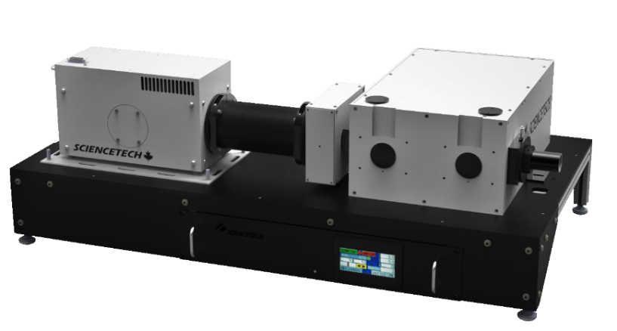
Test Standard: CE Compliant.

Sciencetech offers a series of computer-controlled adjustable sources of monochromatic light, our Tunable Light Source (TLS) line. Each TLS system is pre-aligned at the Sciencetech test lab and packaged with the system’s test data and detailed manual. Sciencetech’s tunable light sources are motorized instruments controlled by Sciencetech’s Windows based software. LabView drivers, ActiveX and DotNet modules are also available making the TLS a flexible system for integration with your experiment or instrument.

Test Purpose:

Sciencetech’s software, Sci-Spec, controls all components of the system. In the standard configuration, it controls the power supply of the light source, shutter, filter wheel, and monochromator. As an option, the user can add computer control on the input and output slits, and/or control of the iris. In the standard configuration, the output beam can be collimated or focused. Coupling with different devices is available as an option, such as coupling with a sample chamber, fiber, or fiber bundle.

Applications: Absorption / transmission / reflection measurement systems, Operable as an excitation light source in fluorescence, measurement systems, Eye protection products measurement system, PEC photochemistry measurement systems, Solar cell quantum efficiency measurement systems.

Standard Features

Each base model comes with standard features:
- Sciencetech Light Source Xe or QTH
- 1” optics are used to collimate light output¹
- Sciencetech Monochromator, three-grating turret with two gratings
- Adjustable slits for optical bandpass control
- Motorized filter wheel with 4 long pass filters installed.
- Adjustable computer controlled power supply.
- SciSpec software for controlling the monochromator and filter wheel.
- Reinforced optical base plate.
Technical Specifications

MODELS | TLS-72-X300 | TLS-72-Q250 | TLS-55-X300 | TLS-55-Q250
Lamp Type | Xe 300 W | QTH 250 W | Xe 300 W | QTH 250 W
Monochromator Type | 9072S (1/8 meter) |  | 9055 (1/4 meter)
Functional Spectral Range | 300-1800 nm
Optical resolution | 0.5 nm @ 300-450 nm |  | 0.2 nm @ 300-450 nm
Optical resolution | 1 nm @ 450-2500 nm |  | 0.4 nm @ 450-2500 nm
Filter wheel with filter set | Computer-controlled 6-position filter wheel
Shutter | Optional computer-controlled shutter and exposure control
Beam output | Collimated with 25 mm [1”] diameter optics¹
Wavelength Repeatability | 0.1 nm
Wavelength Accuracy | 0.3 nm |  | 0.2 nm
Intensity Control | Source intensity adjustable. | Optional manual iris
Gratings | 2 plane ruled gratings  (30x30 mm): |  | 2 plane ruled gratings  (50x50 mm):
Gratings | 1200 l/mm@300nm |  | 1200 l/mm@300nm
Gratings | 600 l/mm@1000nm |  | 600 l/mm@1000nm
Bandpass | Two manual bilaterally-adjustable slits with vertical curtain attenuators
Optical Height | 215 mm [8.5”], adjustable +/- 5 mm
Power supply | Touchscreen, Constant Current
Software | Sci-Spec (Labview examples, DotNet, Active X also available)
Computer Interface | USB—monochromator and filter wheel , RS232 Power Supply
Dimensions (mm) | 822 ×418 × 332 |  | 921 × 545 × 332
Weight | 30 kg |  | 37 kg
CE Certification | IEC 61010-1:2010 Safety Requirements for electrical equipment for measurement, control and laboratory use—Part 1
CE Certification | IEC 61326-1:2012 Electrical equipment for measurement, control and laboratory use—EMC requirements—Part 1

- Quantum Efficiency
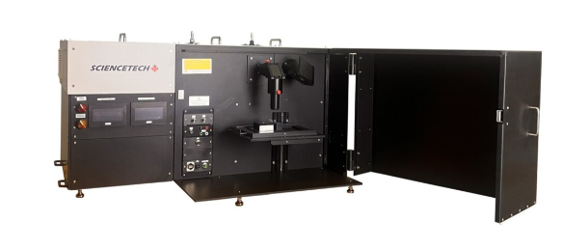
Test Standard: CE Compliant. Compliance: Intended for use in measurements according to ASTM E 1021-15 , ASTM E948, IEC 60904-8, IEC 60904-1

Test Purpose:

Sciencetech PTS system conducts SR, EQE, IQE and IV measurements with user friendly software. The system includes a main xenon arc lamp, monochromator with automated order sorting filters, a steady-state solar simulator Class AAA bias light source ( only with PTS-2 ) measurement electronics, computer, and software required to measure solar cell characteristics. The system provides users with a light tight sample chamber for all measurements. Shielded and light tight test area enclosure has convenient removable cover allowing access from top, front and sides.

Applications: Photovoltaic Solar Cell Testing, IV Characterization, Spectral Response, External Quantum Efficiency-IPCE, Internal Quantum Efficiency (PTS2-IQE Model), Photoconductivity Measurement, Reflectance Measurements Capability.

Features: Spectral Range 250-2500 nm, Tunable Light Source, Source Measure Unit, Lock-in Amplifier, Light Tight Sample Chamber, User Selectable Bias Voltage, AC and DC Measurement Mode, Manually Controlled Shutter, SciPV software for full control of the system.

Measurement Capabilities |  | PTS 1 SR (175-9203) | PTS 2 QE/IPCE (175-9204) | PTS 2 IQE (175-9205)
Current-Voltage (IV) Testing | Measures V_{OC} , I_{SC}, R_{shunt}, P_{max}, efficiency %, and fill factor | - | Included | Included
Spectral Response (SR)* | 250 - 2500 nm scanning range | Included | Included | Included
External Quantum Efficiency (EQE) | Incident photon to converted electron ratio (IPCE) | Included | Included | Included
AC and DC measurement mode | Modulated / Continuous measurement capability | Included | Included | Included
Internal Quantum Efficiency (IQE) | The ratio of charge carriers collected by the cell to the number of photons absorbed by the cell | ---- | ---- | Included  300 - 1100 nm

Technical Specifications

Configuration Description |  | PTS 1 SR (175-9203) | PTS 2 QE/IPCE (175-9204) | PTS 2 QE+IQE (175-9205)
Tunable Light Source | · 150 W Xenon short arc lamp, 1200 hour lifetime | • | • | •
Tunable Light Source | · 250 - 2500 nm tuning/scanning range (Xenon) | • | • | •
Tunable Light Source | · 1/4 m Czerny-Turner monochromator with an adjustable bandpass of 0.4 to 48 nm with 600 l/mm grating , 0.2-24 nm with 1200 l/mm grating | • | • | •
Tunable Light Source | · Motorized triple grating turret system (3 gratings included):  · 1200 l/mm blazed at 250 nm  · 1200 l/mm blazed at 500 nm  · 600 l/mm blazed at 1000 nm | • | • | •
Tunable Light Source | · Adjustable beam size ( 0.5mm - 19 mm diameter with standard optics) | • | • | •
Tunable Light Source | · Includes hard coated order sorting filters | • | • | •
Bias Light Source | · 150 W Xenon short arc lamp, average lifetime 1200 hours | - | • | •
Bias Light Source | · 25x25mm AAA, (ASTM E927-19) Solar Simulator |  | • | •
Bias Light Source | · Includes mounted AM1.5G filter + additional filter slot | - | • | •
Reference Detector | · Broadband pyroelectric detector with quartz window, Element diameter: 5 mm | • | • | •
Reference Detector | · Calibrated range 250 - 2500 nm | • | • | •
Measurement System | · Source meter, maximum 30 W, 30 V, 1 A | • | • | •
Measurement System | · Voltage accuracy 30 µV and current accuracy 10 pA | • | • | •
Measurement System | · Measurement time period for 100 IV points is 20s | • | • | •
Measurement System | · Voltage bias user settable ±10 V capability | • | • | •
Measurement System | · Lock-in Amplifier | • | • | •
Measurement System | · Chopper 4 - 200 Hz | • | • | •
Measurement System | · Standard auto time constant feature | • | • | •
Measurement System | · Temperature control (10-60 °C) ⁽¹⁾ | Accessory Available | Accessory Available | Accessory Available
Measurement System | · Ac and DC measurement mode | • | • | •
IQE Measurement System | · 50 mm integrating sphere | - | - | •
IQE Measurement System | · Internal quantum efficiency measurement determined from material reflectance measurement (hardware included) 300 - 1100nm range. | - | - | •
Sample Placement | · 50 × 50 mm simple sample spacer for proper placement of the sample under the monochromatic and bias light beam. Includes simple electrical connections. | • | • | •
Software and Interface | · Modern software written in .NET (Windows 10/11 Operating System) | • | • | •
Software and Interface | · Compatible with Windows 10/11, 32/64bit | • | • | •
Software and Interface | · Data files and automation log exportable as ASCII | • | • | •
Software and Interface | · Pre-configured and tested control computer included | • | • | •
Software and Interface | · Built in microcontroller switches and monitors signals automatically | • | • | •
Software and Interface | · 1 USB port | • | • | •
Software and Interface | · 1 IEC 60320 C14 power entry inlet | • | • | •
Compliance | · Intended for use in measurements according to ASTM E 1021-15 , ASTM E948, IEC 60904-8, IEC 60904-1 | • | • | •
Power system | · Single phase, configurable for 230 VAC, 50 Hz or 110 VAC, 60 Hz | • | • | •

- Light Pipe Solar Simulator

. 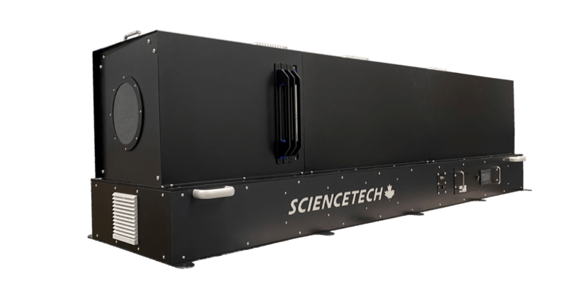

Test Standard: CE Compliant, Standard for Classification: ASTM E927-19.

Test Purpose:

The SLP series of solar simulators can be configured to give precedence to certain specifications of interest, in accordance with your requirements. Some features are related, and maximizing one specification may reduce another. Four main distinctions maximize certain features (HF: High Flux, COL: Collimated, HOM: Homogenized, and LA: Large Area).

Each SLP includes a lamp housing, power supply, arc lamp, air mass filter, standard fixed frame, and testing report.

Applications: Satellite Sun Loading Testing, Photochemistry, Material Characterization, Degradation Testing, Photovoltaic Testing, Accelerated Age Testing, Thermal Energy Storage System Testing (High Flux).

Features

- Range of working distances and target sizes.
- Each unit includes a power supply, xenon short arc lamp and AM filter (if specified).
- Homogenizing optics provide uniform irradiance Distribution.

Technical Specifications

Model | SLP-100-COL | SLP-150-COL | SLP-320-COL | SLP-320-HOM | SLP-500-LA | SLP-200-HF
Spectral Match⁴ | AM 1.5G Class A  AM0 Class A⁸
Spatial Non-Uniformity | B | B | C | A | C | C
Temporal Instability | A
Standard for Classification | ASTM E927-19
Target Size (mm) | 100  (diameter) | 150  (diameter) | 320  (diameter) | 320  (diameter) | 500×500 | 200×200
Target Shape | Hexagonal |  |  |  | Square
Working Distance | 1-3m⁵ |  |  |  | 0.2-1.0m⁵ | 0.1-0.5m⁵
Maximum Irradiance² | 1.0 Suns (AM0)  1.2 Suns (AM1.5G)  1.5 Suns (Unfiltered) |  |  |  |  | 8 suns (AM0)  10 suns (AM1.5G)  15 suns (Unfiltered)
Sun Type | AM1.5G, AM0, Unfiltered
Collimation Half Angle³ | <0.5 | <0.9 | <0.9 | <8 | <20 | N/A
Lamp Power (W) | 1600 | 2500 | 6500
Lamp Type | Xenon short arc
Illumination Direction | Horizontal⁷
Dimensions (L x W x H) (mm) | 2500 × 500 × 600⁶ |  | 3000 × 1000 × 1500⁶
Weight (kg) | 140⁶ |  | 200⁶
Power Supply Model | 611-1.6k | 621-2.5k | 631-6.5k-480-B⁴
Power Requirements | 220-240VAC, 50/60 Hz, 2500 VA | 220-240VAC, 50/60 Hz, 4400 VA | 380-480VAC, 50/60 Hz, 7000 VA (380-480 V p-p, 3p+E)

- Monochromator
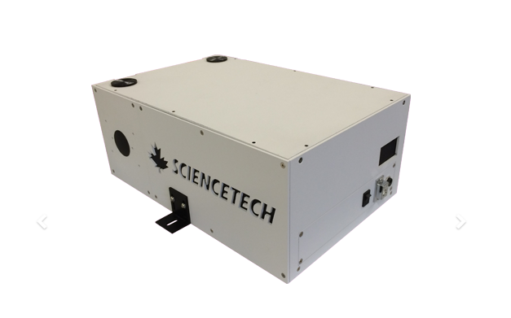

Test Standard: CE Compliant

Test Purpose:

The Sciencetech standard series monochromators offer a flexible and customizable choice of monochromator with the full functionality afforded by motorized wavelength control and a multiple grating turret. The design features asymmetric Czerny-Turner optical layout, using up to 3 plane-ruled gratings with an f/3.5 aperture. An adjustable slit is included for the input port. Additional slit options and several accessories are available. For applications requiring better signal to noise, reduced stray light and better resolution than the standard model, a double monochromator (9055DX) in double additive mode is available. For applications requiring a tunable bandpass or notch filter light source, the double subtractive mode is an ideal choice.

Applications: Tunable monochromatic light source, Spectroscopic systems, Emission and source characterization, Absorbance, transmittance and reflectance measurement, High dispersion or high-power density spectral illumination system, Electrochemical spectroscopy, Fluorescence spectroscopy, Scanning spectrophotometry, Raman spectroscopy.

Features

- Highly customizable modular design
- Two configurable input and output ports
- Interchangeable turret design to allow more than three grating options
- Configurable turret and grating options
- USB2.0 communication
- Fully integrated software and development libraries available
- Full line of input and output accessories
Technical Specifications

Model | 9055 | 9055F | 9055DA | 9055DS | 9057 | 9057F
Input Focal Length (mm) | 200 |  |  |  | 457
Output Focal Length (mm) | 250 |  |  |  | 457
Wavelength Selection | Motorized
Communication | USB
Readout Mechanics | Direct drive stepping motor
Aperture | f/3.5 | f/2.5 | f/3.5 |  | f/8 | f/5.9
Maximum Grating Size | 50 × 50 | 64 × 64 | 50 × 50 |  |  | 64 × 64
(mm × mm)
Number of Gratings | 3 | 2 | 3 |  |  | 2
Optical Resolution (nm) ¹ | 0.2 | 0.4 | 0.09 | 0.2 | 0.1 | 0.2
Stray Light ² | 4 × 10⁻⁵ |  | 1 × 10⁻⁵ |  | 3 × 10⁻⁵
Dispersion (nm/mm)¹ | 4 |  | 1.7 | 0 | 1.79
Wavelength Accuracy (±nm) ¹ | 0.2 | 0.4 | 0.2 | 0.2 | 0.1 | 0.2
Wavelength Reproducibility (±nm) ¹ | 0.1 | 0.1 | 0.1 | 0.1 | 0.1 | 0.1
Flat Field Size (mm) | 25 | 25 | 25 | N/A | 25 | 25
Flat Field Angle (°) | -1.69 | -1.69 | Call | Call | -1.4 | -1.4
Optical Axis Height (mm) | 76.2 | 86.4 | 76.2
Dimensions (mm) | 391 × 255 × 156 |  | 588 × 406 × 165 |  | 624 × 318 × 168
Weight (kg) | 7.5 | 10 | 20 |  | 9

- High Flux Solar Simulators

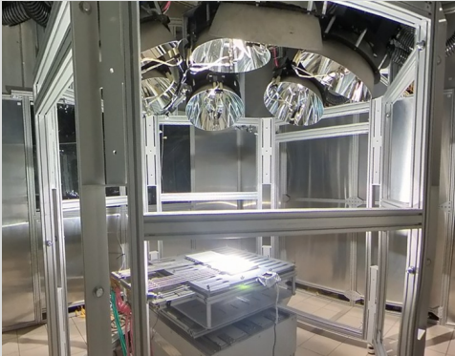

Test Standard: CE Compliant

Test Purpose:

Sciencetech’s High Flux Solar Simulator (HFSS) systems are used for a variety of applications that require intense and controlled light conditions. They are essential in developing and testing solar receivers and reactors, which are used in concentrating solar power (CSP) systems to convert sunlight into thermal energy.

These simulators are also used to test thermal energy storage systems, which store heat for later use, ensuring they can effectively capture and release energy under different conditions.
Additionally, HFSS are employed in materials science to study the behavior of materials under high-temperature and high-radiative flux conditions.

They are also used in aerospace engineering to test thermal protection systems for space vehicles, ensuring these materials can withstand the extreme conditions of space travel.

By providing a stable and repeatable light source, HFSS enable researchers to conduct experiments without the variability caused by natural sunlight, leading to more accurate and reliable results.

Applications: Concentrated Solar power, Thermal energy Storage, Thermochemical Reactions, Material Testing.

Features

- 3MW/m² Peak Irradiance.
- Complete Ready to use Systems.
- Focused 6.5kW Xenon Arc Lamps.
- Touchscreen Power Supply and Software Control.
- Systems Can Be Customized to Meet Your Exact Needs
Technical Specifications

Performance Specifications
Illumination Area: | Focused Spot, ~30 mm Diameter
Typical Working Distance [mm]: | 1372.8
Lamp Type: | XE6500
Average Lamp Lifespan: | 750 hours
Physical Specifications
 | Radiative Modules | Control Rack | Downward Facing Stand | Power Supply
Typical Weight [kg]: | 30 | 105 | 360 | 27
Dimensions [mm]: | 703 x 574 x 568 | 550 x 654 x 1285 | 2505.5 + 406.4 x 1727 x 1727 | 657 x 266 x 483
Operating Environment: | Indoor, well-ventilated environment. Not for household application.
Operating Temperature Range [°C]: | 15 – 30
Operating Humidity Range [%RH]: | <80%, non-condensing
Electrical Specifications: 631-6.5k-480 Power Supply (per power supply)
Voltage [rms]: | 380 – 480 VAC 3P
Frequency: | 50/60 Hz
Maximum Current [rms]: | 16.8 A
Fuses: | CC Time – Delay 25 A, 600 V
Electrical Specifications: 631-6.5k-220 Power Supply (per power supply)
Voltage [rms]: | 200 – 240 VAC 3P
Frequency: | 50/60 Hz
Maximum Current [rms]: | 31.3 A
Breaker: | 50 A
Fuses: | 1 A, 600 V
Electrical Specifications: Radiative Module (per radiative module)
Rated Voltage: | 39 V
Rated Operating Current: | 133 – 173 A
Electrical Specifications: Global Safe Control Box
Voltage [rms]: | 100 – 240 VAC 1P
Frequency: | 50/60 Hz
Maximum Current [rms]: | 3 A
Fuses: | 1.0 A, 250 V, Slo-blo  6.3 A, 250 V, Slo-blo
Certifications
CE Declaration of Compliance: | Yes

- Ultra High Efficiency Solar Simulator (UHE)
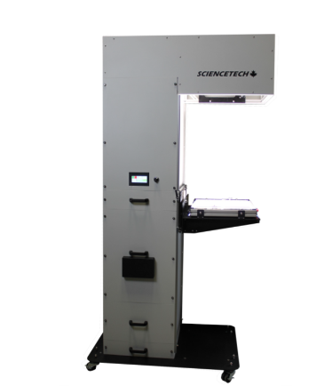
Test Standard: CE Compliant.
Our simulators are designed to meet the following standards: - ASTM E 927, IEC 60904-9, JIS C 8912.
Testing is performed to meet ASTM E927-19

Test Purpose:

The UHE-NS and UHE-NL solar simulator series are class AAA and have turn key operation system. Due to their very high efficiency these can be used for larger target areas and larger distances.
The UHE-NS/NL family of solar simulators are feature rich, convenient integrated systems suitable for a variety of research and testing requiring a stable and reliable uniform light source. UHE-NL series solar simulators can produce 1 Sun or more solar irradiance at a variety of solar spectral classifications (with an appropriate AM filter).
All of the electronics are contained inside the UHE-NL system to reduce clutter. With the UHE-NL all of the simulator functions can be controlled from a single touch screen interface or from the provided Sciencetech Power Control software.

Applications: Photovoltaic Testing, Material Characterization and Degradation Testing, Photochemistry, Accelerated Age Testing.

Features

- Industry Leading Efficiency.
- Class AAA.
- Turn-key Operation.
- Suitable for larger target areas.
- Electronic shutter control.
- Includes AM1.5G Filter.
- Vertical with option for horizontal operation.

Technical Specifications

Model | UHE-NS-75 | UHE-NS-100 | UHE-NL-150 | UHE-NL-200 | UHE-NL-250 | UHE-NL-300
SKU Number | 166-9026 | 166-9026 | 166-9028 | 166-9029 | 166-9030 | 166-9031
Solar Simulator Type | Steady-State
Test Plane Area. 1 Sun. AM1.5G (mm) | 75x75 | 100x100 | 150x150 | 200x200 | 250x250 | 300x300
Test Plane Area. 1 Sun. AM0 (mm) | 50x50 | 70x70 | 100x100 | 140x140 | 175x175 | 200x200
Solar Simulator Classification | AAA
Spectral Range (nm) | 300-1800
Spectral Match Classification | Class A. All intervals (0.75 < RSM* > 1.25). Different Spectral filters available.
Spatial non-uniformity of Irradiance Classification | < 2% |  |  |  |  | < 3%
Spatial non-uniformity of Irradiance Classification | A
Temporal Instability of Irradiance Classification | A
Collimation Half angle (degrees) | <8 |  |  | <9 |  | <10
Typical Working Distance (mm) | 225 |  | 500 | 575 | 650
Lamp Type | Xenon Short Arc
Lamp Wattage (watts) | Model | 300, (XE300) |  | 1000, (XE1000) |  | 1600, (XE1600)
Irradiance Control | 0.8 - 1 sun
Control Unit | Integrated Touchscreen Control Unit
Dimensions (L×W×H) (mm) | See Dimensions Page.
Weight (kg) | 80 |  | 95
Power Supply Model | Integrated
Power Requirements | 100-120V, 50-60Hz 4A or 200-240V, 50-60Hz 2A |  | 100-120V, 50-60Hz 10A or 200-240V, 50-60Hz 5A | 220-240V/ 50Hz, 10A

- PSS-Series Large Area Flash/Pulsed Solar Simulator

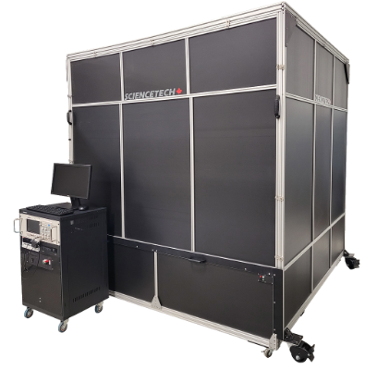

Test Standard and Test Purpose:

The PSS-series of flash (or pulsed) solar simulators are designed to illuminate large photovoltaic devices up to 2 × 2 m in size with up to 1 sun irradiance, with spectral matching to terrestrial (AM1.5G) or space (AM0) conditions. Spectral match must be selected at the time of order and cannot be changed after production. The system comes with an included device trolley, with a tilted target plane calibrated for the system.

These systems are based on a heavy-duty xenon flash lamp, combined with spectral filtering and a built-in beam conditioning reflector. The standard flash measurement window is 0.2 ms, but an optional pulse current regulator can be selected to allow for a flat, stable pulse within a measurement window of 4.0 ms.

- Our AM1.5G flash system is manufactured to achieve up to Class AAA, and our AM0 flash system is manufactured to achieve up to Class B to current IEC standards. ASTM standards
testing is available upon request.
- The system uses a heavy-duty xenon flash lamp and AM1.5G calibrated solar filter to approximate the sun’s true spectral distribution following IEC 60904-9Ed.3.0 Class A standards
- Evaluated according to IEC 60904-9 Ed3.0
- The Large Area Flash Solar Simulator offers a Class A spectral match to ASTM E927 standards using an AM0 filter (no spectral standard for AM0 is available under IEC 60904-9 Ed.3.0).
- The Large Area Flash Solar Simulator offers a Class A spectral match to IEC 60904-9 Ed.3.0 standards using an AM1.5G filter.
- CE Compliant.

Technical Specifications

MODEL | PSS-AM1.5G-1 | PSS-AM1.5G-1.5 | PSS-AM1.5G-2 | PSS-AM0-1 | PSS-AM0-1.5 | PSS-AM0-2
Spectral Range (nm)¹ | 300 - 1200 |  |  | 300 - 1400
Air Mass Filter | AM1.5G |  |  | AM0
Uniform Illumination Area² (m) | 0.9 × 0.9 | 1.5 × 1.5 | 1.9 × 1.9 | 0.9 × 0.9 | 1.5 × 1.5 | 1.9 × 1.9
Solar Simulator Classification³ | AAA | ABA | ABA | BBA | BBA | CBA
Spectral Match Classification^{3,4} | Class A |  |  | Class B |  | Class C
Spatial Non-Uniformity Classification³ | Class A | Class B | Class B | Class A | Class B | Class B
Temporal Instability Classification³ | Class A |  |  | Class A
Working Distance (cm)⁷ | 7.5 |  |  | 7.5
Maximum Irradiance (W/m²)⁸ | 1500 |  | 1200 | 1100
Maximum Irradiance (Suns) | 1.5 |  | 1.2 | 1.1
Mechanical Attenuation Range⁹ | 0.4-1.0 |  |  | 0.4-1.0
Irradiance Monitor | Built-in Si reference device, calibrated for 1 Sun |  |  | Built-in Si reference device, calibrated for 1 Sun
Temperature Monitor¹⁰ | RTD PT100 |  |  | RTD PT100
Flash Head | Air cooled, max 2400J without pulse current regulator  Air cooled, max 4800J with pulse current regulator |  |  | Air cooled, max 2400J without pulse current regulator  Air cooled, max 4800J with pulse current regulator
Lamp Type | Xenon flashtube, max 4800J |  |  | Xenon flashtube, max 4800J
Lamp Lifetime | 20,000 - 25,000 flashes (at 1 Sun) |  |  | 20,000 - 25,000 flashes (at 1 Sun)
Wavelength Control | Integrated filter, replaceable |  |  | Integrated filter, removeable
Pulse Measurement Window⁶ | 0.2 ms without pulse current regulator  4.0 ms with pulse current regulator |  |  | 0.2 ms without pulse current regulator  4.0 ms with pulse current regulator
Typical Time Between Flashes (sec) | 2 |  |  | 2
Line Voltage Options | 120V, 220V |  |  | 120V, 220V

- SF SOLAR SIMULATOR, Small Area Collimated Lens Based, Class AAA and ABA

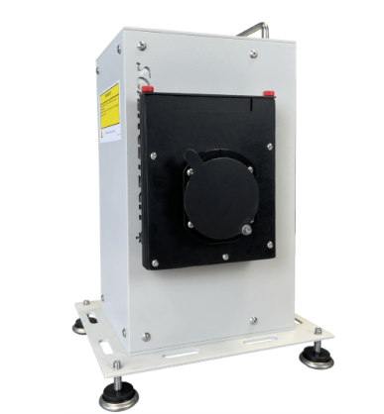

Test Standard:
- According to ASTM E927
- CE Compliant.

Test Purpose:

Sciencetech’s SF Solar Simulators (Steady State) are low cost lens based systems designed for researchers who do not require a large field of illumination. SF series solar simulators produce 1 Sun and are available in Class A or B uniformity.
The beam can be projected horizontally (standard) or vertically with the use of a downward-facing stand.
Sciencetech SF series solar simulators produce a highly collimated output and are an ideal choice for space based research or systems needed high levels of collimation.

Applications: Semiconductor characterization, Photovoltaic Solar Cell Testing, UV Exposure Testing, Sunscreen Testing, Cosmetics Testing, Environmental Testing, Electrochemical.

Features

- Economical Design.
- Up to Class AAA Specification.
- Touchscreen Power Supply.
- Turn Key Operation.
- Collimated Systems Available.
- Manual Shutter Included.
- Electronic Shutter Optional.
- Multiple Optional Accessories.
- Lamp Life Timer.
- Air Mass AM0/AM1.5 Filters.
Technical Specifications

Model | SF
Part Number | 300 | 150
Solar Simulator Classification | AAA to UBA | ABA to UBA
Spectral Range (nm) | 250-2000
Spectral Match Classification¹ | Up to A
Spatial non-uniformity | < 2% | < 5%
Non-Uniformity Class | A | B
Temporal Stability Classification | A
Target Diameter (mm) | 25 to 50 | 50
Working Distance (mm) | 100-130
Collimation | 1.0 degree half angle²
Power Level at Target (AM1.5G Standard — 100mW/cm²) | 1 Sun
Center Beam Line Height (mm) | 137
Lamp Power (W) | 300 | 150
Power Supply Model | 601-300 | 601-150
Dimensions (LxWxH) (mm) | 222 x 183 x 318
Weight (kg) (with power supply) | 6 (12)
Power Supply Input | 110-240V, 50Hz/60Hz , 450W
Operating Current (A) | 5-20
Stability / Ripple / Regulation | 0.05% / < 1% / 0.02% current variation for 5V line charge

- Research Grade Xenon, Arc Lamp Sources, Low/Med Power 75W - 300W

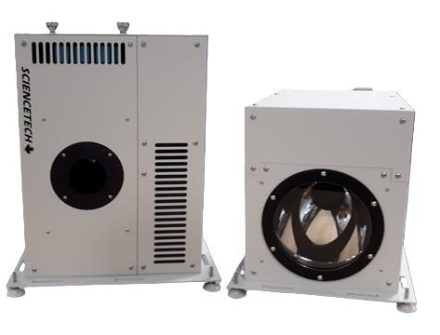

Test Standard: CE Compliant.

Test Purpose:

Sciencetech offers a selection of arc lamp sources for research applications. Short arc lamps are high-pressure discharge lamps. These lamps are especially suitable for optical applications because of their high radiance and luminance. Light is generated by a discharge arc burning freely between two electrodes. The length of the arc is determined by the distance between the two electrodes, which is usually only a few millimeters. This makes arc lamps an ideal point source of light.
This brochure focuses on Sciencetech’s xenon arc lamp sources, with the lamp envelope filled with high-pressure xenon gas, providing a wide range of wavelengths of illumination.
These lamp houses are designed to operate in a vertical or horizontal mode, and come with base plates for both orientations included.

Applications: Coatings Durability Testing, Photobiology, Photochemistry, Spectroscopy.

Features

- Vertical or horizontal housing operation
- Xenon arc lamps from 500W to 1600W, lamp included
- Multiple collimated or focused output optics in various sizes, materials, and coatings
- User-friendly design
- Numerous available accessories
- Standard safety interlocks.

Light Source Package

Product Code | Description of Research Grade Arc Lamp Source | Collimated or Focused | Power (W) | Aperture Ratio | Lens configuration | Clear Aperture (mm) | Material
 |  |  |  | (F/#) | Lens configuration | Clear Aperture (mm) | Material
102-9150 | 500 W Collimated Research Grade Arc Lamp Source, 2 inch, One Lens, Fused Silica, O₃-free | Collimated | 500 | - | A | 50.8 | FS
102-9151 | 500 W Focused Research Grade Arc Lamp Source, 2 inch, F/3.0, Two Single Lenses, Fused Silica, O₃-free | Focused | 500 | 3.0 | A ( COL and IO Optics) ) | 50.8 | FS
102-9152 | 1000 W Collimated Research Grade Arc Lamp Source, 2 inch, One Lens, Fused Silica, O₃-free | Collimated | 1000 | - | A | 50.8 | FS
102-9153 | 1000 W Focused Research Grade Arc Lamp Source, 2 inch, Two Single Lenses, F/3.0, Fused Silica, O₃-free | Focused | 1000 | 3.0 | A ( COL and IO Optics) ) | 50.8 | FS
102-9154 | 1600 W Collimated Research Grade Arc Lamp Source, 2 inch, One Lens, Fused Silica, O₃-free | Collimated | 1600 | - | A | 50.8 | FS
101-9155 | 1600 W Focused Research Grade Arc Lamp Source, 2 inch, Two Single Lenses, Fused Silica, F/3.0, O₃-free | Focused | 1600 | 3.0 | A ( COL and IO Optics) ) | 50.8 | FS

